

**MAB Sales Management System (MHSMS)**

**SYSTEM OPERATION DOCUMENT**

**MAB/GROUP IT/SOD/MHSMS/1.6**

**Prepared by:**

**MHSMS Development Team**

**Application Management Services (AMS)**

**Group IT**

**ALL INFORMATION CONTAINED HEREIN IS RESTRICTED AND SHALL BE KEPT FOR INTERNAL USE ONLY**. None of this information shall be divulged to persons other than MalaysiaAirlinesBerhad employees and contractors authorized by the nature of their duties to receive such information, or individuals or organisations authorised by Malaysia Airlines Berhad in accordance with existing policy regarding release of company information.

**INTENTIONALLY LEFT BLANK**

|  |  |  |  |
| --- | --- | --- | --- |
| Prepared By | : |  |  |
|  |  | Krishnakant Bairagi |  |
|  |  | MHSMS Support Team |  |
|  |  | Application Management Services |  |
| Reviewed By | :  : | |  | | --- | |  | | Suman Guduru | | OST Tower Manager | | Group IT | |  |
|  |  | Noor Hafiza Bahruddin |  |
|  |  | IT - Service Delivery Management |  |
|  |  | Group IT |  |
|  | : |  |  |
|  |  | Noraini Abdul Hamid |  |
|  |  | System Owner  Manager CML - Sales Development - Sales |  |
| Approved By | : |  |  |
|  |  | Siti Hafsah Mohd Desa |  |
|  |  | Head IT Service Delivery Manager |  |
|  |  | Group IT |  |

**INTENTIONALLY LEFT BLANK**

**TABLE OF CONTENTS**

**Contents Page**

PART 1 - MANUAL ADMINISTRATION 1-1

1.1. RECORD OF REVISION 1-2

1.2. LIST OF EFFECTIVE PAGES 1-3

1.3. DISTRIBUTION LIST 1-4

1.4. LIST OF ABBREVIATIONS 1-4

1.5. CONDITION OF USE 1-5

1.6. CONTROL OF MANUAL 1-5

PART 2 - MANUAL BACKGROUND 2-1

2.1 INTRODUCTION 2-2

2.2 PURPOSE 2-2

2.3 SCOPE AND APPLICATION 2-2

2.4 TERMINOLOGY 2-2

2.5 REFERENCES 2-2

PART 3 – OVERVIEW OF BUSINESS PROCESS 3-1

3.1 OVERVIEW OF BUSINESS PROCESS 3-2

PART 4 – MANUAL CONTENT 4-1

4.1 Systems overview 4-2

4.2 SYSTEM CONCEPT DIAGRAM 4-5

4.3 INTERFACES 4-5

4.3.1 User Interfaces 4-5

4.3.2 System Interfaces 4-9

4.4 WARRANTY AND MAINTENANCE PERIOD 4-10

4.5 ROLES AND RESPONSIBILITIES 4-10

4.6 Technical specifications 4-12

4.6.1 Hardware specifications 4-12

4.6.2 Software specifications 4-13

4.6.3 Communication / Network Specification 4-14

4.6.4 User and Equipment Locations 4-16

4.6.5 File Management 4-16

4.7 Technical operations guide 4-16

4.7.1 Installation Procedures 4-16

4.7.2 Backup and Recovery 4-16

4.7.3 System Startup and Restart 4-17

4.7.4 System Shutdown 4-17

4.7.5 Monitoring Tools 4-17

4.7.6 Source Code Version Control 4-17

4.7.7 Batch Jobs 4-18

4.7.9 Report Management 4-18

4.8 Maintenance and support 4-19

4.8.1 Problem Logging 4-19

4.8.2 Problem Categorization and Escalation 4-19

4.8.3 Application / Technical Support 4-20

4.9 User guide 4-21

4.9.1 Accessing the Application 4-21

4.10 Contract management 4-22

4.11 Handover items 4-23

4.12 Information security 4-24

4.13 Documentation and references 4-26

AppendiX i

1. - MANUAL ADMINISTRATION

# RECORD OF REVISION

| **No.** | **Description of Changes** | **Issue No.** | **Rev. No.** | **Author** | **Effective Date** |
| --- | --- | --- | --- | --- | --- |
| 1 | Initial version | 1 | 0 | Reshma PR | 15-Apr-16 |
| 2 | Updated the document with application enhancements | 1 | 1 | Asish Mathew | 03-Apr-17 |
| 3 | Updated the document to latest formats | 1 | 2 | Navin Neelamegam | 28-Dec-17 |
| 4 | Added CHG0011551 details - Automation of contract status reports | 1 | 3 | Anurag Nikhil Minz | 06-Dec-17 |
| 5 | Updated appendix with change request details | 1 | 4 | Anurag Nikhil Minz | 22-May-18 |
| 6 | Updated version and AMS support team changes | 1 | 5 | Deepti Jain | 05-Oct-19 |
| 7 | Updated the Contract Management | 1 | 6 | Prashant Chauhan | 25-June-20 |

# LIST OF EFFECTIVE PAGES

|  |  |  |  |  |  |  |  |  |  |  |
| --- | --- | --- | --- | --- | --- | --- | --- | --- | --- | --- |
| **Part** | **Page** | **Issue No.** | **Revision No.** | **Effective Date** |  | **Part** | **Page** | **Issue No.** | **Revision No.** | **Effective Date** |
| 1 | 1-1 | 1 | 2 | 28-12-17 |  |  | 4-17 | 1 | 2 | 28-12-17 |
|  | 1-2 | 1 | 2 | 28-12-17 |  |  | 4-18 | 1 | 2 | 28-12-17 |
|  | 1-3 | 1 | 4 | 22-05-18 |  |  | 4-19 | 1 | 2 | 28-12-17 |
|  | 1-4 | 1 | 4 | 22-05-18 |  |  | 4-20 | 1 | 4 | 22-05-18 |
|  | 1-4 | 1 | 4 | 25-06-20 |  |  |  |  |  |  |
|  | 1-5 | 1 | 4 | 22-05-18 |  |  | 4-21 | 1 | 2 | 28-12-17 |
| 2 | 2-1 | 1 | 2 | 28-12-17 |  |  | 4-22 | 1 | 2 | 28-12-17 |
|  | 2-2 | 1 | 2 | 28-12-17 |  |  | 4-23 | 1 | 2 | 28-12-17 |
| 3 | 3-1 | 1 | 2 | 28-12-17 |  |  | 4-24 | 1 | 2 | 28-12-17 |
|  | 3-2 | 1 | 2 | 28-12-17 |  |  | 4-25 | 1 | 2 | 28-12-17 |
| 4 | 4-1 | 1 | 2 | 28-12-17 |  |  | 4-26 | 1 | 2 | 28-12-17 |
|  | 4-2 | 1 | 2 | 28-12-17 |  |  | 4-26 | 1 | 6 | 25-06-20 |
|  | 4-3 | 1 | 2 | 28-12-17 |  |  | 4-27 | 1 | 2 | 28-12-17 |
|  | 4-4 | 1 | 2 | 28-12-17 |  |  |  |  |  |  |
|  | 4-5 | 1 | 2 | 28-12-17 |  |  |  |  |  |  |
|  | 4-6 | 1 | 2 | 28-12-17 |  |  |  |  |  |  |
|  | 4-7 | 1 | 4 | 04-08-20 |  |  |  |  |  |  |
|  | 4-8 | 1 | 2 | 28-12-17 |  |  |  |  |  |  |
|  | 4-9 | 1 | 2 | 28-12-17 |  |  |  |  |  |  |
|  | 4-10 | 1 | 4 | 22-05-18 |  |  |  |  |  |  |
|  | 4-11 | 1 | 2 | 28-12-17 |  |  |  |  |  |  |
|  | 4-12 | 1 | 4 | 22-05-18 |  |  |  |  |  |  |
|  | 4-13 | 1 | 2 | 28-12-17 |  |  |  |  |  |  |
|  | 4-14 | 1 | 2 | 28-12-17 |  |  |  |  |  |  |
|  | 4-15 | 1 | 2 | 28-12-17 |  |  |  |  |  |  |
|  | 4-16 | 1 | 2 | 28-12-17 |  |  |  |  |  |  |

# DISTRIBUTION LIST

|  |  |  |
| --- | --- | --- |
| **NAME** | **DEPT / AREA** | **DESIGNATION** |
| Siti Hafsah Mohd Desa | Group IT | Head IT SDM |
| Wan Mohd Husni Wan Hussein | AMS | AMS SDM |
| Noraini Abdul Hamid | Manager  CML - Sales Development | System Owner |
| Noor Hafiza Bahruddin | Group IT | IT - Service Delivery Management |

Table 1: Distribution List

# LIST OF ABBREVIATIONS

The following are the abbreviations used for the purpose of simplification.

|  |  |
| --- | --- |
| **Abbreviation** | **Denote** |
| BU | Business Users |
| BCD | Business Critical Definition |
| DBA | Database Administrator |
| Group IT | Group Information Technology division |

Table 2: Abbreviations

# CONDITION OF USE

1. This manual is the property of Malaysia Airlines Berhad.
2. All copies assigned to individual position(s), section(s) or station(s) is on loan basis. If, for any reason, the position(s), section(s) or station(s) is abolished from the company organization, the respective copy(ies) of the manual must be returned to Head IT Service Delivery Manager.
3. In the event where the title of the position or section is changed, the department concerned shall inform Head IT Service Delivery Manager promptly.
4. The content of this manual shall not be copied, or communicated in part or as a whole, to any person not employed by the Company without the express written consent of the Head IT Service Delivery Manager.
5. It is the responsibility of the holder to ensure that his copy is updated to the latest amendments and is in good state of condition.

# CONTROL OF MANUAL

1. The contents of this manual shall not be deleted, added, or altered in any way without the approval of the Head IT Service Delivery Manager.
2. Any page which carries an amendment must bear the new revision date. Any line which is amended shall be highlighted by a revision bar (i.e. dark vertical line) drawn close to the amended text on the outside border of the document.
3. A transmittal letter must accompany the amended pages to advise the holders how to effect the amendment to their copies.
4. Holders shall notify this department in writing for loss of manual and to obtain a replacement copy. Head IT Service Delivery Manager shall ensure that this manual reviewed at least once a year and effect necessary amendments as and when necessary. Should any person(s) envisage improvements needed for the contents of this manual, the person should direct the request to the Head IT Service Delivery Manager.

**INTENTIONALLY LEFT BLANK**

1. - MANUAL BACKGROUND

# INTRODUCTION

This is the MHSMS SOD, hereinafter referred to as “the Policy” provides comprehensive operating procedures within the scope and application herein defined in Part 2 Section 3.0 for Malaysia Airlines Berhad (MAB).

# PURPOSE

The objective of this document is to provide relevant information required to operate and support “MHSMS” application. The platform is ready for implementation and handover to IT Operations.

# SCOPE AND APPLICATION

This SOD covers relevant information required to operate and support the MHSMS to a certain extent and will be dependent on the product vendor as MAB does not own the source codes of the MHSMS application.

# TERMINOLOGY

| **No** | **Term** | **Description** |
| --- | --- | --- |
| 1 | UAT | User Acceptance Test |
| 2 | DR | Disaster Recovery |
| 3 | DB | Database |
| 4 | SOD | System Operational Document |
| 5 | SOW | Statement of Work |

Table 3: Terminology

# REFERENCES

| **No** | **Document** | **Description** |
| --- | --- | --- |
| 1 | User Guide | User Guide |
| 2 | SOW | Statement of Work as supplied as agreed upon between TCS and MAB |
| 3 | Technical Design Document | Document highlighting the Technical Design & architecture of the collaboration platform. This is supplied by TCS |
| 4 | Test Plan Document | Document highlighting the Test plan for the collaboration platform. This is supplied by TCS |
| 5 | Functional Document | Document highlighting all the functional requirements of the system. This is supplied by TCS |

Table 4: Document Reference

1. – OVERVIEW OF BUSINESS PROCESS

# 

# OVERVIEW OF BUSINESS PROCESS

The below figure depicts overview of business process,

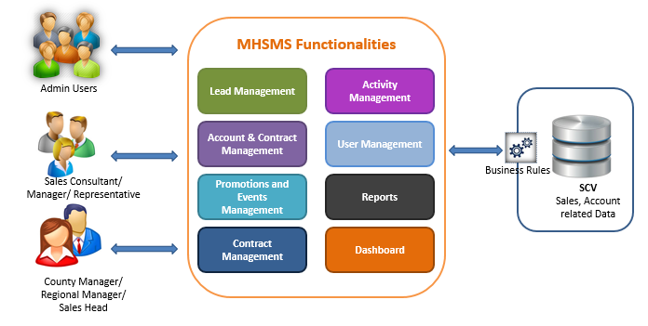

Figure 1: Application architecture

The existing Sales Management System is not robust and also doesn’t have features that are available in modern day systems. In order to overcome this issue, a new application has been developed. The new system is called MH Sales Management System, which have existing features and new features like Workflow management, Statistics, Reports, Dashboards and proper management of Sales. MHSMS will use SCV DB and application will be categorized under SCV Application.

1. – MANUAL CONTENT

# 4.1 Systems overview

New system MAB Sales Management System (MHSMS) developed with the below features.

* Lead Management Feature

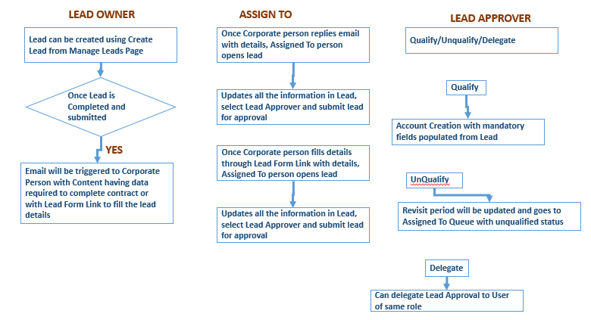

Figure 2: Application process workflow

* Account and Contact Management Feature - Basic workflow is mentioned below

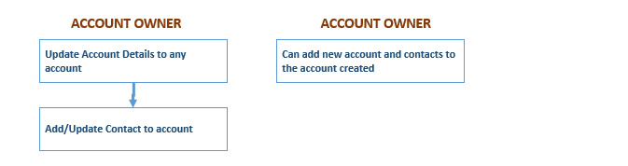

Figure 3: Basic workflow

* Contract Management Feature – Contract Management feature is having functionalities as mentioned below.

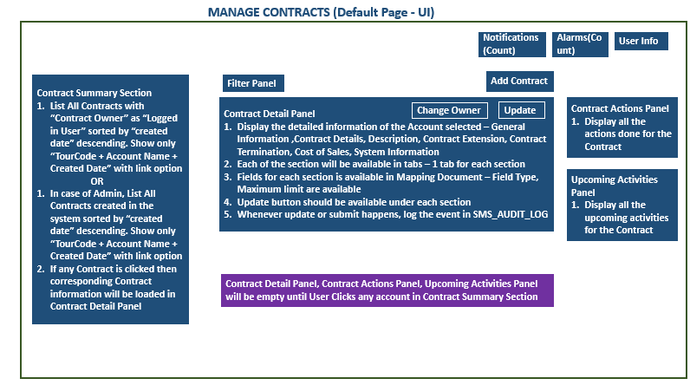

Figure 4: Manage Contract

* Promotions Management Feature – Promotion Management feature is having functionalities as mentioned below.

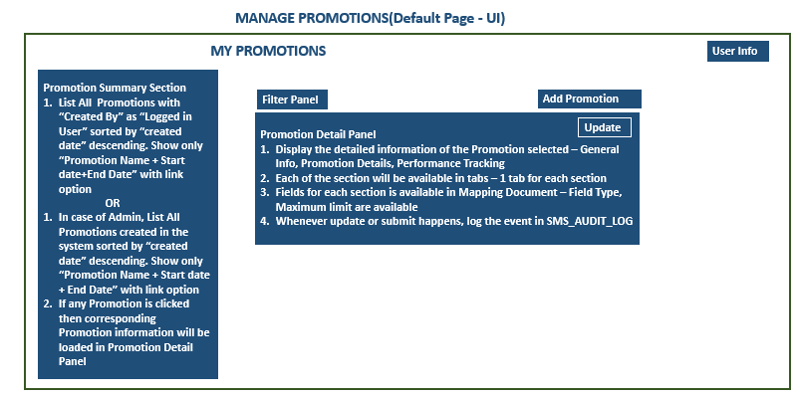

Figure 5: Manage promotion

* Events Management Feature –Event Management feature is having functionalities as mentioned below.

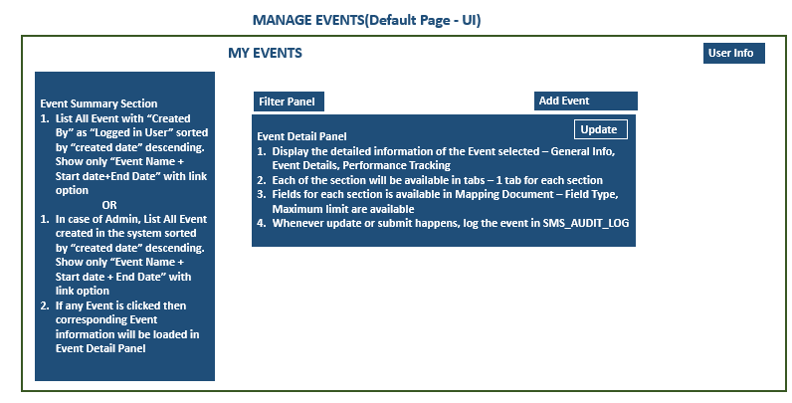

Figure 6: Manage events

* Activity Management Feature – Activity Management feature is having functionalities as mentioned below.

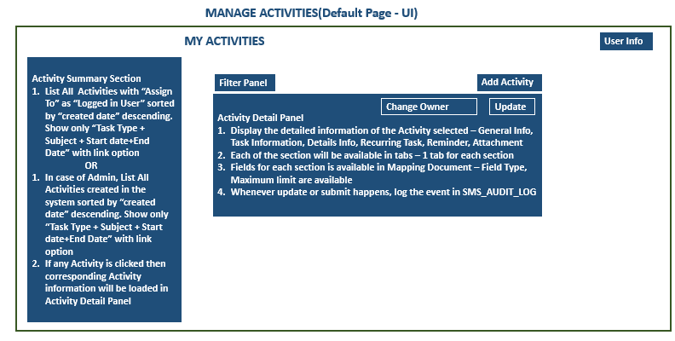

Figure 7: Manage activities

# 4.2 SYSTEM CONCEPT DIAGRAM

The overall logical System architecture is as per diagram shown below:

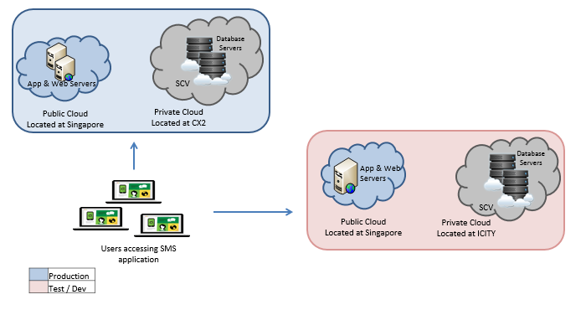

Figure 8: System Architecture

# 4.3 INTERFACES

## 4.3.1 User Interfaces

The following are the User interfaces in the MHSMS System

* Log in page
* Business user will be given access to SMS system by SMS Admin
* A user with legitimate MH credential will be able to logon
* Credential keyed in by the user will be validated against LDAP system credentials
* On successful validation, users can access the features defined for his role.

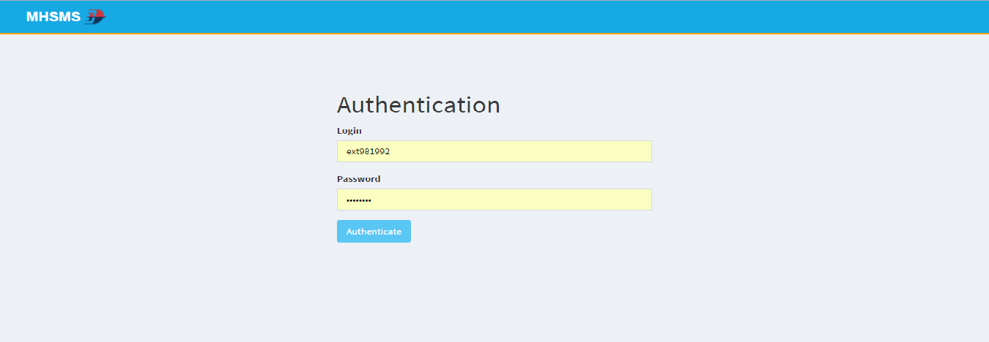

Figure 9: Login page

1. Lead Management

Used to create new leads, submit leads, qualify/un-qualify leads, update leads, revisit leads, lead notifications and email notification.

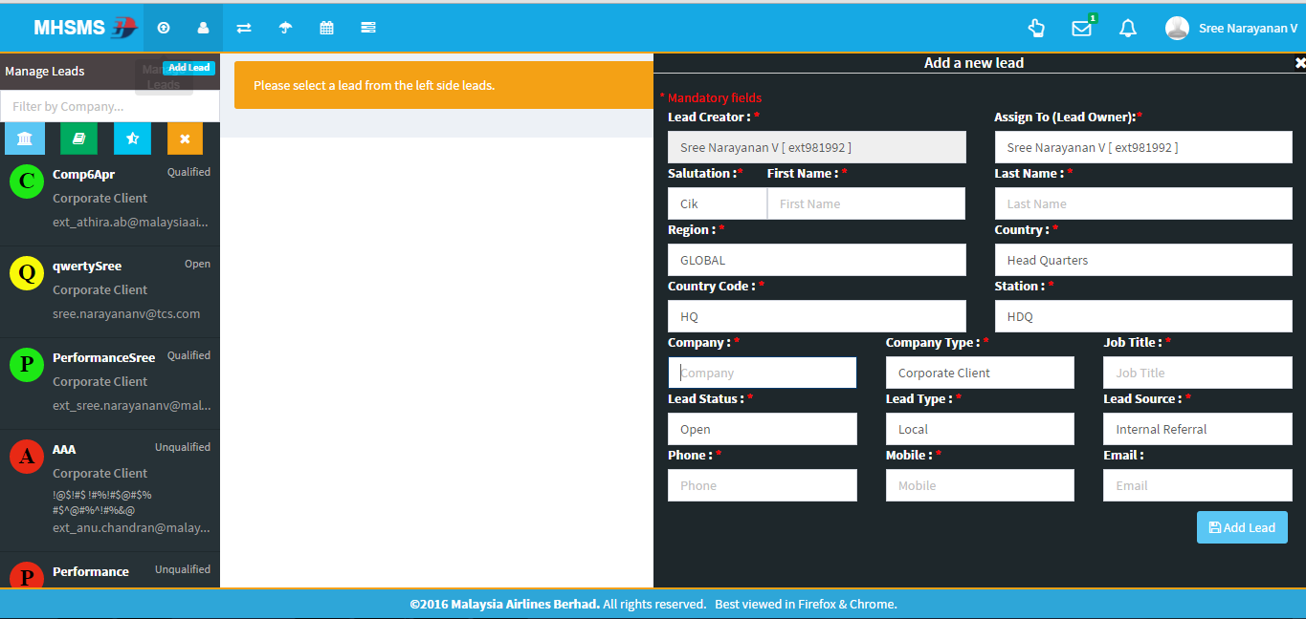

Figure 10: Lead Management UI

1. Account Management

Used to create new account (automatically when lead is qualified/manually), add/update/delete contacts to account, update accounts

Figure 11: Account management UI

1. Contract Management

Used to update contract, contract renewal, contract expiry notifications, email notification, Activity details

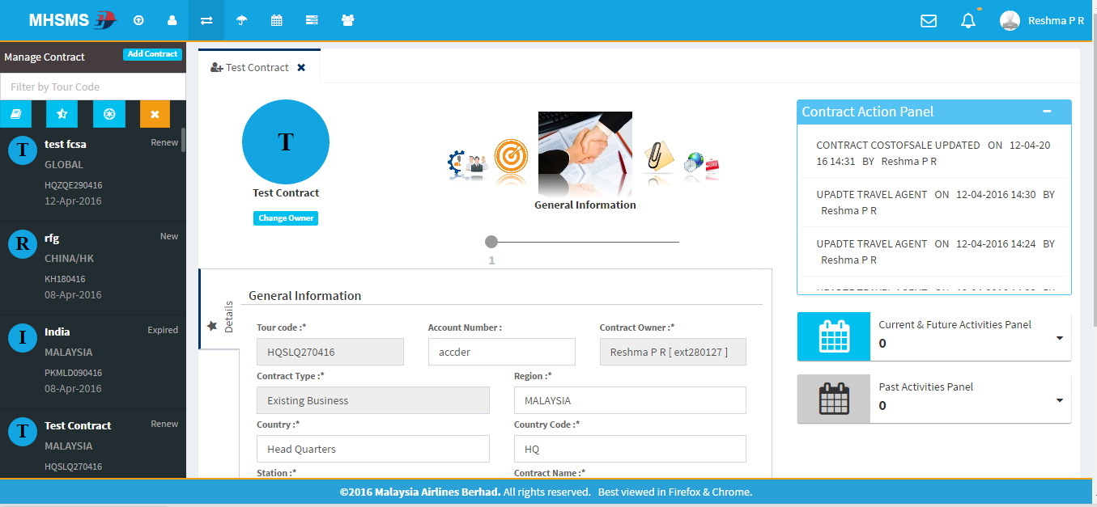

Figure 12: Contract Management UI

1. Promotion Management (Figure5)

Used to create/update/delete promotions

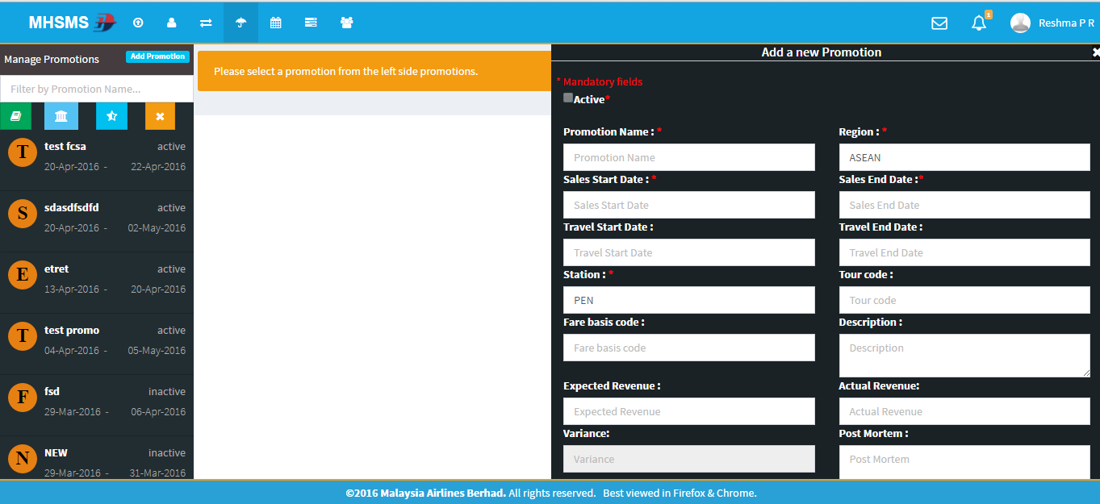

Figure13: Promotion Management UI

1. Event Management (Figure6)

Used to create/update/delete Events

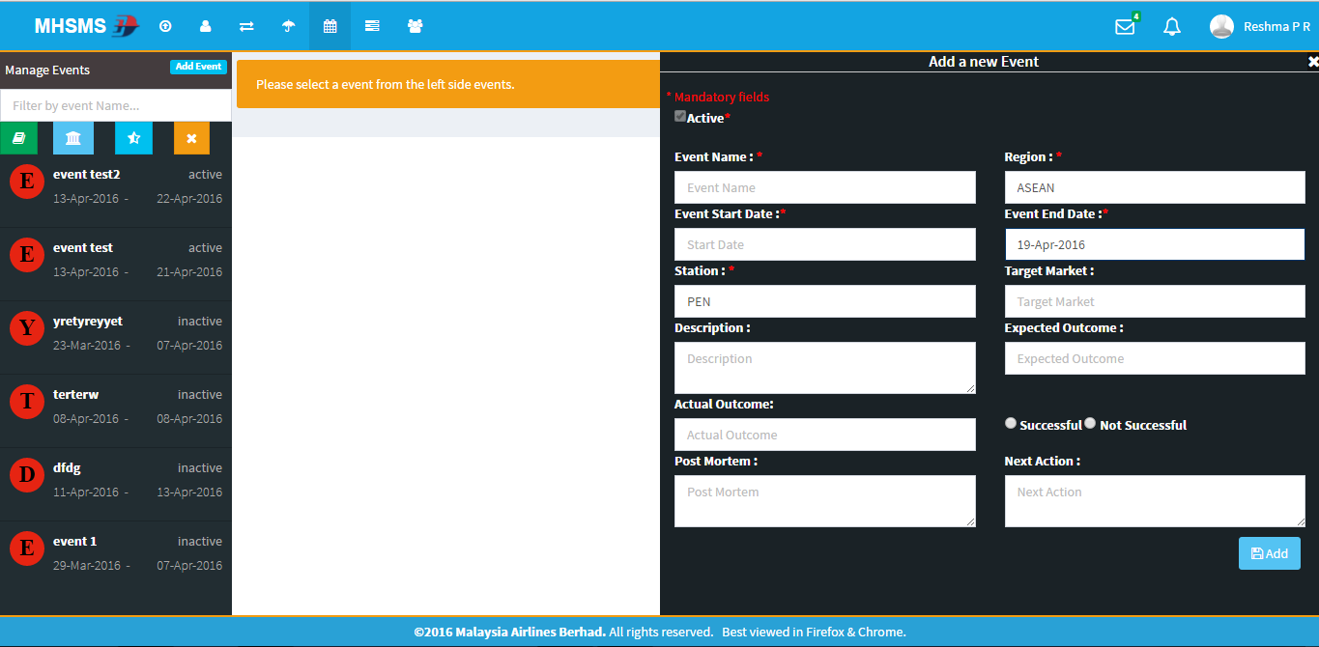

Figure14: Event management UI

1. Activity Management (Figure7)

Used to create/update/delete activities, activity module has mapping to leads/account/opportunity/contract modules

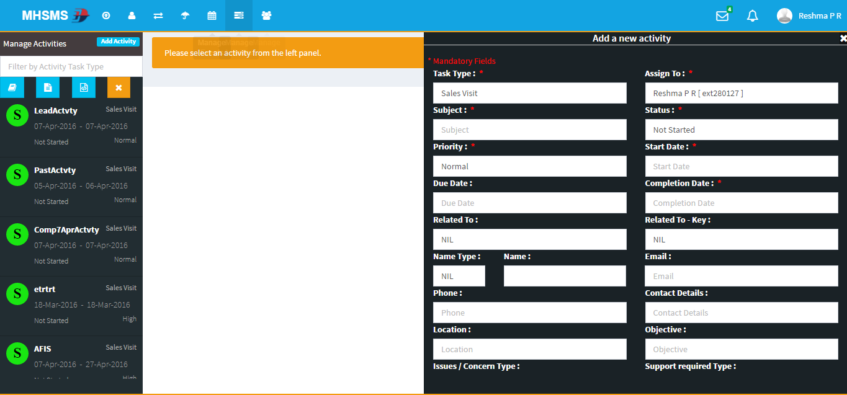

Figure15: Activity Management UI

1. User Management (Figure8)

The users can view and edit roles and features using user management.

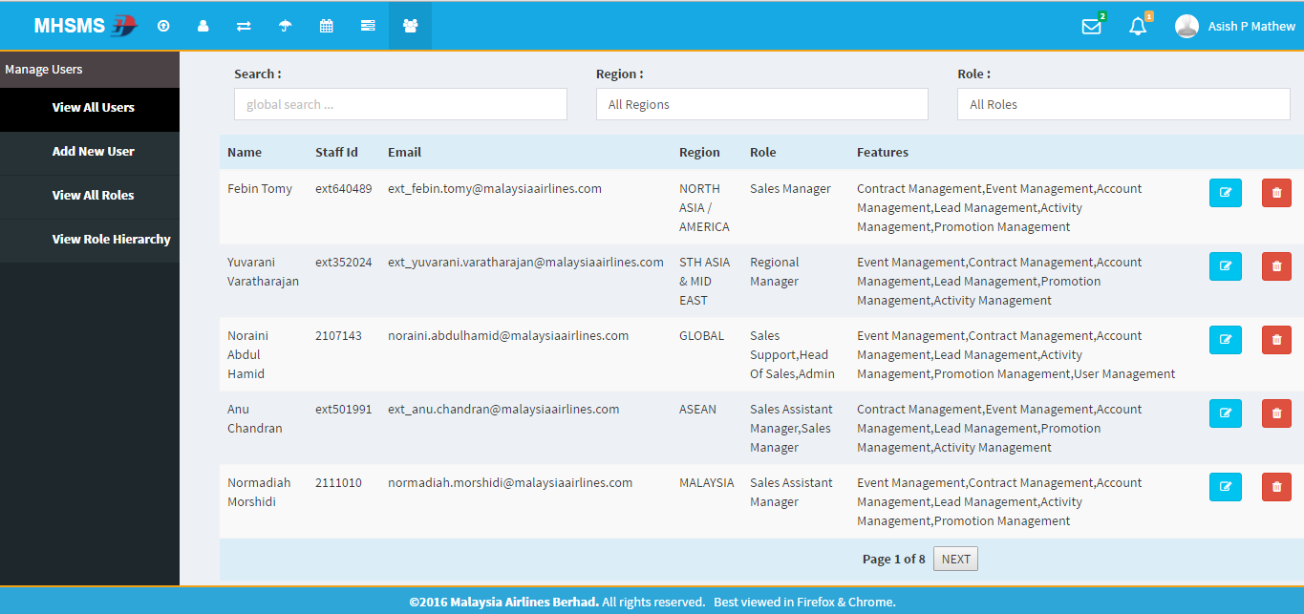

Figure16: User management UI

## 4.3.2 System Interfaces

Interface with MAB Corporate Active Directory

MHSMS is having integration with the Active Directories (LDAP) for Security Authentication purposes. The integration with Active Directories shall adopt the existing standards currently practiced by Group IT.

User can login into application using MH domain credentials and it will be validated using LDAP Validator

|  | **Interfaced system** | **Description** | **Transfer Mode** |
| --- | --- | --- | --- |
| 1. | LDAP | The application is interfaced with the LDAP active directory to validate and get user information. | HTTPS protocol |

Table 5: System Interfaces

# 4.4 WARRANTY AND MAINTENANCE PERIOD

|  |  |  |
| --- | --- | --- |
| **Warranted Items** | **Start Date** | **End Date** |
| Warranty period | 01-Jun-2018 | 31-Jun-2018 |
| Maintenance and Support contract | 01-Jan-2017 | 30-Sep-2018 |

Table 6: Warranty and Maintenance period

# 4.5 ROLES AND RESPONSIBILITIES

|  |  |  |  |  |  |
| --- | --- | --- | --- | --- | --- |
| **Role** | **Responsibility** | **Name** | **Designation** | **Company / Department** | **Contact (Phone & Email)** |
| System owner | Ensure system is operating as per designed and authorize user access to the system. | Noraini Abdul Hamid | Manager | Commercial | noraini.abdulhamid@malaysiaairlines.com |
| System Admin | Responsible for installation, configuration, patching, and monitoring system performance | Anurag Nikhil Minz | Application Admin | TCS | +60172882148  ext_anurag.nikhilminz@malaysiaairlines.com |

Table 7: Roles and Responsibilities

MAB IT Helpdesk will provide the first level support for MHSMS. Users will call the MAB IT Helpdesk for the first-level problem determination. Based on the severity and findings, the problem is to be channeled to the respective support team.

Infra and AMS Team will provide the second level support for the application infrastructure

The second level support team coverage and their role/responsibility are listed below:

| **Role** | **Responsible Party / Responsibility** |
| --- | --- |
| MHSMS Administration | * Infra Mid-Range tower. * Administer the MHSMS PROD and TEST servers. * Perform the operating system and application backup/recovery. * Manage server security as per security policy. * Monitoring of the systems resources and ensure servers performance and availability is per SLA. * Gatekeeper for application fixes deployment. * Troubleshooting infrastructure related problems. * Perform OS and Postgres AS patches maintenance and implement upgrade or patch releases. |
| MHSMS Application Support | * AMS * 2nd level application support. * Coordinating application fixes and upgrade deployment   + perform UAT together with BU   + raise RFC for CAB * Coordinating with Infra to deploy fixes and upgrade   + Verify fixes together with BU * Reports and Monitoring the application technical problem |
| MHSMS Postgres Database Administration | * Infra Database tower * Perform database maintenance and implement Postgres upgrade or patch releases. * Perform database recovery. * Manage database security as per security policy. |
| Tivoli Monitoring Administration | * IT-Ops Infra Mid-Range tower. * Ensure all components (hardware resources, daemons) of application are monitored and abnormal system behaviours are informed to operators and Application System Administrator. |
| Commvault Storage Management | * IT-Ops Infra Mid-Range tower * Monitor Linux, applications, Postgres DB are backup as per schedule backup via Commvault |
| MHSMS User’s PC administration | * Desktop Support |
| WAU Group | * Responsible for monitoring the application server system health and TEC messages. * Responsible to escalate problems detected from TEC console and error log |
| MAS Helpdesk | * Single point of contact to coordinate when the problems occurred. * Responsible to coordinate problem reporting to the respective parties. |

Table 8: Roles and Responsibilities

# 4.6 Technical specifications

## 4.6.1 Hardware specifications

The MHSMS hardware infrastructure as follows:

|  |  |  |
| --- | --- | --- |
| **Category** | **Server Name** | **Configuration** |
| Production Application Server | MASG-1MHSMSAPP1  (public – Singapore) | IP Address : 10.221.4.56 DNS Name : 1mhsmsapp1.mas.net Azure VM Size : Standard A2_v2 (2 cores, 4 GB memory) OS Version : RHEL 7.2 CPU : 2 Memory (GB) : 4 SWAP (GB) : 8 |
| Production Web Server | MASG-1MHSMSWEB1  (public – Singapore) | IP Address : 10.221.2.15 DNS Name : 1mhsmsweb1.mas.net Azure VM Size : Standard A2_v2 (2 cores, 4 GB memory) OS Version : RHEL 7.2 CPU : 2 Memory (GB) : 4 SWAP (GB) : 8 |
| Test Server | MASG-3MHSMSAPP1  (public – Singapore) | IP Address : 10.221.12.48 DNS Name : 3mhsmsapp1.mas.net Azure VM Size : Standard A2_v2 (2 cores, 4 GB memory) OS Version : RHEL 7.2 CPU : 2 Memory (GB) : 4 SWAP (GB) : 8  DB server: 3scvdb1.mas.net  IP Address: 10.221.14.22 |
| Production DB |  | IP Address: 10.221.6.50  DNS Name: 1scvpgdb.mas.net |

Table 9: Hardware Specifications

*.*

## 4.6.2 Software specifications

The MHSMS software infrastructure as follows:

|  |  |  |
| --- | --- | --- |
|  | **Category** | **Configuration** |
|  | Application | MHSMS  Modules:   * Login * Lead Management * Account Management * Contract Management * Promotion Management * Event Management * Activity Management * User Management |
|  | Programming language | UI :  Angular JS, HTML, CSS, Angular-ui-bootstrap, JavaScript  Server:  JAVA 1.8, Spring MVC, Hibernate  DB:  HQL, SQL |
|  | Build Automation tool | Apache Maven |
|  | Front-end screen | Chrome 47+,IE9+, Mozilla Firefox45+ |
|  | Server Operating System | RHEL 7.2 |
|  | Database | Postgres 11.6 |
|  | Operating system | Windows |

Table 10: Software specifications

## 4.6.3 Communication / Network Specification

|  |  |  |
| --- | --- | --- |
|  | **Category** | **Configuration** |
|  | Protocol | Server: HTTP  Client: HTTP  Mail : SMTP |

Table 11: Network specifications

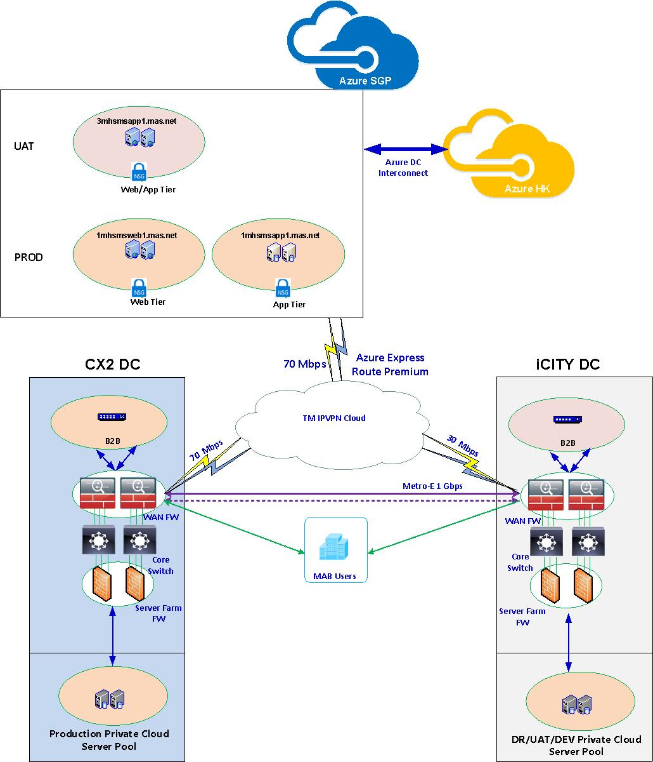

Figure 17: Network Architecture

## 4.6.4 User and Equipment Locations

**Server:**

|  |  |  |  |  |
| --- | --- | --- | --- | --- |
|  | **Name** | **Location** | **Contact Name** | **Contact No** |
| 1 | MASG-1MHSMSAPP1  (public – Singapore) | MASG Azure | GD_TCSMidrange | 180081702 - 3 |
| 2 | MASG-1MHSMSWEB1  (public – Singapore) | MASG Azure | GD_TCSMidrange | 180081702 - 3 |
| 3 | MASG-3MHSMSAPP1  (public – Singapore) | MASG Azure | GD_TCSMidrange | 180081702 - 3 |

Table 12: Server details

## 4.6.5 File Management

|  |  |
| --- | --- |
| **Libraries and files** | **Location (mount point)** |
| Tomcat | /tomcat |
| Apache | /usr/local/apache |

Table 13: File management

# 4.7 Technical operations guide

This section describes all technical activities to be performed by IT Operations to operate and maintain the system

## 4.7.1 Installation Procedures

NA

## 4.7.2 Backup and Recovery

Recovery Services vault is an entity that stores all the backups and recovery points that have been created over time. The vault also contains the backup policies that will be applied to the virtual machines being backed up

When the Recovery service initiates a backup job at the scheduled time, it triggers the backup extension to take a point-in-time snapshot. The Azure Recovery service uses the VMSnapshot extension in Windows, and the VMSnapshotLinux extension in Linux. The extension is installed during the first VM backup.

Once the Azure Backup service takes the snapshot, the data is transferred to the vault. To maximize efficiency, the service identifies and transfers only the blocks of data that has changed since the previous backup.

When the data transfer is complete, the snapshot is removed and a recovery point is created.

|  |  |  |  |  |
| --- | --- | --- | --- | --- |
| **Server/Database** | **# of Versions** | **Frequency** | **Schedule (MYT)** | **Remarks** |
| MASG-1MHSMSAPP1 | 6 | Every Saturday | 5:50 PM MYT | Monthly first Saturday backup retention is 3 months |
| MASG-1MHSMSWEB1 | 6 | Every Saturday | 5:50 PM MYT | Monthly first Saturday backup retention is 3 months |
| MASG-3MHSMSAPP1 | 6 | Every Saturday | 5:50 PM MYT | Monthly first Saturday backup retention is 3 months |

Table 14: Backup and recovery

## 4.7.3 System Startup and Restart

|  |  |  |
| --- | --- | --- |
|  | **Procedure** | **Description** |
| 1 | Tomcat -> bin -> startup.sh | To start the tomcat server |

Table 15: System startup

## 4.7.4 System Shutdown

Below is a list of procedure to bring down the system:

|  |  |  |
| --- | --- | --- |
|  | **Procedure** | **Description** |
| 1 | Tomcat -> bin -> shutdown.sh | To stop the tomcat server |

Table 16: System shutdown

Note: Tomcat Application services gatekeeping by Midrange team and all other issues related to application related services has to be addressed by AMS team

## 4.7.5 Monitoring Tools

The MHSMS Production servers, Apache and Tomcat processes will be monitored by IBM Tivoli Monitoring. Refer to TEC Events Escalation Procedure.

## 4.7.6 Source Code Version Control

***MHSMS Binaries***

|  |  |
| --- | --- |
| **Binaries** | **Description** |
| mhsms.war | B1 branch binary |
| mhsms.war | B2 branch binary |

Table 17: Binaries

AMES executables are store in the following path :

* *http://10.250.29.30/svn/SRAS/SRAS/MHCSMS/Binaries/RL_02_02-MAY-2016/mhsms.war.*
* *http://10.250.29.30/svn/SRAS/SRAS/MHCSMS/Binaries/RL_01-23-APR-2016/mhsms.war.*

The first path is to store B2 branch binary

The latter path is to store the B1 branch binary

## 4.7.7 Batch Jobs

Job scheduled via a Cron Job to execute

1. To make promotion inactive – This is to make the promotion inactive after the sales end date.
2. To make event inactive – This is to make the event inactive after the event end date.
3. To activate contract – This will change the status of contracts with New/Renew status to active status after 30 days from the contract start date.
4. To make contract expired – This will make the contracts expired once the expiry date is reached.
5. To make contract terminated – This will make the contract terminated once the termination date is reached.
6. Contract expiry notification mail – Email will be sent to contract owners before 10,20,30,45,60 days of contract expiry.
7. Activity reminder mail - Reminder mail will be sent to the person to whom the task is assigned. By default the mail will be triggered one day before starting the activity. This can be edited either in the add activity or update activity section.
8. Monthly contract status report – Monthly contract status report will be sent to the Key users.

## 4.7.9 Report Management

NA

# Maintenance and support

This section provides information to Help Desk personnel who are expected to receive problem or error reports from MHSMS users.

## 4.8.1 Problem Logging

Users will log problem tickets to Helpdesk. All problems will be escalated the MHSMS for resolution

## 4.8.2 Problem Categorization and Escalation

## 

|  |  |  |
| --- | --- | --- |
| **Severity** | **Code** | **Definition of severity level** |
| Critical | S1 | Total biz operation disruption |
| High(Urgent) | S2 | Partial biz operation disruption |
| Moderate(Minor) | S3 | No critical impact to biz operations, work around is available |
| Low(Monitor) | S4 | Problem that cause inconvenience |

Table 18: Problem categorization and escalation

|  |  |  |  |  |
| --- | --- | --- | --- | --- |
| **Business Unit** | **Business Unit** | **1st Level Support** | **2nd Level Support** | **3rd Level Support** |
| Business Users | Business Support Personnel | IT Helpdesk | IT Operations   * AMS | IT Operations   * AMS |
| IT Operations   * Infra |  |

Table 19: Problem categorization

* Business Support will provide the initial usage support to users.
* If the problem cannot be resolved by Business Support Personnel, it will then be escalated to MAB IT Helpdesk first level support for further investigation.

A problem ticket will be created by the Level 1 MAB Helpdesk and route to the MAB second level support for application related problem to AMS team, system related problem to MVS Infra team and database related problem to DBA team.

## 4.8.3 Application / Technical Support

For all Infra related problem, Helpdesk will channel the problem ticket to the following support personnel:

|  |  |  |
| --- | --- | --- |
| **Name** | **Responsibility Area** | **Contact (Email)** |
| IT Helpdesk | L1 support | [helpdesk@malaysiaairlines.com](mailto:helpdesk@malaysiaairlines.com) |
| Rajendra Prasad | Midrange | [ext_rajendra.prasad@malaysiaairlines.com](mailto:ext_rajendra.prasad@malaysiaairlines.com)  GD_TCSMidrange <GD_TCSMidrange@malaysiaairlines.com> |
| Abdul | Wintel | [ext_abdulkhader.mohamedabusali@malaysiaairlines.com](mailto:ext_abdulkhader.mohamedabusali@malaysiaairlines.com)  GD_TCSWintel <GD_TCSWintel@malaysiaairlines.com> |
| Abhinav Kishore | Database | [ext_abhinav.kishore@malaysiaairlines.com](mailto:ext_abhinav.kishore@malaysiaairlines.com)  GD_TCSDatabase <GD_TCSDatabase@malaysiaairlines.com> |
| Ravisankar | Network Support | [ext_ravisankar.balasubramanian@malaysiaairlines.com](mailto:ext_ravisankar.balasubramanian@malaysiaairlines.com)  GD_TCSNetwork <GD_TCSNetwork@malaysiaairlines.com> |
| Krishnakant Bairagi | Application Support | ext_krishnakant.bairagi@malaysiaairlines.com |
| Group ID | MHSMS support team | [GD_AMS_MHSMS@malaysiaairlines.com](mailto:GD_TCS_MHSMS@malaysiaairlines.com) |

Table 20: Application/ Technical support

# User guide

## 4.9.1 Accessing the Application

MHSMS application is deployed in web based environment, the client workstation uses the web browser to connect to the web server through LAN/WAN. The web server runs the application and communicates with the database server for exchanging the data.

Access MHSMS via URL: **<https://mhsms.malaysiaairlines.com/mhsms/>**

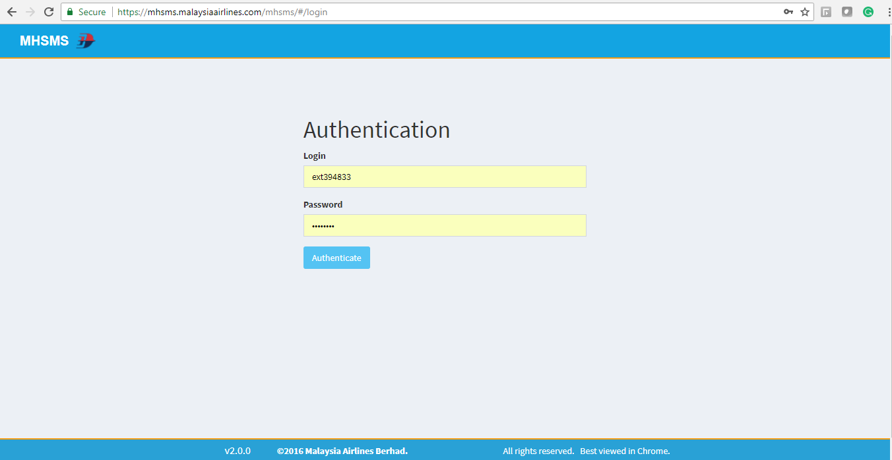

# Contract management

|  |  |  |
| --- | --- | --- |
|  | **Contract** | **Parties** |
| 1. | Service contract from AMS support service | Signed between MAB and ATOS |

Table 21: Contract management

# Handover items

The following documents / items will be handed over to Operations together with this System Operation Document during the Handover session.

1. Technical Design Document
2. System Operation Document
3. Project Document (Refer to Reference section of this document).
4. Technical Training document.
5. User signoff by Business Users

# 4.12 Information security

**4.12.1 AUDIT AND COMPLIANCE REQUIREMENTS**

|  |  |  |
| --- | --- | --- |
| **Activity** | **Frequency** | **Responsible Party** |
| Perform ID review every quarter and submit result to IRS  [Req: ISO 27001, PCI-DSS] | Quarterly | ID Admin |
| Update user access matrix and submit to IRS  [Req: ISO 27001, PCI-DSS] | Yearly | System Owner |
| Install Critical Security Patches for the application and submit report to IRS  [Req: ISO 27001, PCI-DSS] | Quarterly | System Owner |
| Performed Backup restoration  [Req: ISO 27001, PCI-DSS] | Yearly | System Owner |
| Review & update security documentation and submit to IRS:   * Super/privilege IDs and access * Security Controls Setting * Audit Logs setting * System bypass * List of connections and integration * List of used ports * Data encryption setting * Application/system schematic diagram   [Req: ISO 27001] | Yearly | System Owner |

Table 22: Audit and compliance requirements

**4.12.2 PASSWORD POLICY COMPLIANCE**

|  | **Password Policy Requirements** | **Yes** | **No** | **Remarks** |
| --- | --- | --- | --- | --- |
|  | Password length at least 8 characters (minimum) | Yes |  |  |
|  | Alphanumeric | Yes |  |  |
|  | Change temporary password at first logon | Yes |  |  |
|  | Password expiry = 90 days (maximum) | Yes |  |  |
|  | Password reuse generation = 5 (minimum) |  | No |  |
|  | Account lock out after 5 failed login attempts | Yes |  |  |
|  | Application shall disconnect or suspend inactive sessions= 15 Minutes | Yes |  |  |
|  | Wrong password shall be recorded in an audit log |  | No |  |

Table 23: Password and policy compliance

**4.12.3 USER ACCESS MATRIX**

|  |  |  |  |  |
| --- | --- | --- | --- | --- |
| **USER TYPE** | **ACCESS LEVEL** | | | |
| **User Management** | **Report Generation** | **NA** | NA |
| Administrator | Yes | Yes | NA | NA |
| Normal | No | Yes | NA | NA |

Table 24: User access matrix

# 4.13 Documentation and references

|  |  |  |
| --- | --- | --- |
|  | **Document** | **Location of source** |
| 1 | System Operation Document Template | https://mabitdept.sharepoint.com/sites/MyPulse/InformationTechnology/ |

Table 25: Document and References

# AppendiX

**Change Requests**

|  |  |  |  |  |
| --- | --- | --- | --- | --- |
| **Change request** | **Date** | **Description** | **MH fix Included?** | **Impacted version** |
| CHG0010285 | 09-05-2017 | Changing the revenue details charts in Accounts and contracts section | yes | 1.2 |
| CHG0011551 | 06-12-2017 | Automation of contract status reports | yes | 1.3 |
| CHG0012261 | 07-03-2018 | Report Format Change & Adding Mail list | yes | 1.3 |
| CHG0012770 | 23-05-2018 | Discrepancy in auto-generated contract reports | yes | 1.3 |
| CHG0015313 | 19-07-2020 | To add contract extension fields in yearly reports | yes | 1.4 |
| CHG0015434 | 29-07-2019 | To add 5 contract extension fields in yearly reports | yes | 1.5 |
| CHG0015750 | 30-04-2020 | To build PAS integration between MHSMS and 1A Corporate Recognition | yes | 1.6 |
| CHG0017241 | 30-04-2020 | To add a new field (4 char) in MHSMS | yes | 1.6 |
| CHG0018515 | 13-08-2020 | SSO Integration | yes | 1.6 |
| CHG0019689 | 11-02-2021 | Clid changes | yes | 1.6 |
| CHG008517 | 26-02-2021 | DB migration from Oracle to Postgres | yes | 1.6 |
| CHG0020583 | 10-06-2021 | Allowing maswings user into mhsms | yes | 1.6 |

Table 26: Change requests

**PATCH MANAGEMENT REPORT**

Application : ______________________________________________________

Owner **: ______________________________________________________**

|  |  |
| --- | --- |
| **Date** | **Patch / Service Pack Applied** |
|  |  |
|  |  |
|  |  |
|  |  |

**Prepared By: Approved By:**

**.................................................... ....................................................**

**System Admin System Owner**

**BACKUP RESTORATION REPORT**

Application : ______________________________________________________

Owner **: ______________________________________________________**

|  |  |
| --- | --- |
| **Date** | **Status of Restoration** |
|  |  |
|  |  |
|  |  |
|  |  |

**Prepared By: Approved By:**

**.................................................... ....................................................**

**Backup Admin System Owner**

**NON COMPLIANCE REPORT**

Application : ______________________________________________________

Owner **: ______________________________________________________**

|  |  |  |
| --- | --- | --- |
| **Date** | **Reference Number** | **Description** |
|  |  |  |
|  |  |  |
|  |  |  |
|  |  |  |

**Prepared By: Approved By:**

**.................................................... ....................................................**

**System Admin System Owner**

**END OF DOCUMENT**